Rest api

<https://danieleli2.asuscomm.com/api>

# Kontroller [Users](https://danieleli2.asuscomm.com/api/Users)

## GET

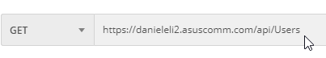

Svar:

[{"id":1,"birthId":null,"password":null,"email":"dee.00123@gmail.com","firstName":"Test","sirName":"Testersen","hasAdmin":true,"active":false},{"id":2,"birthId":null,"password":null,"email":"test@gmail.com","firstName":"test","sirName":"test","hasAdmin":false,"active":false}]

Her er enkelte felter nullet ut for økt sikkerhet.

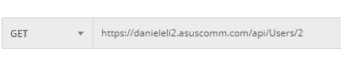

Svar:

{"id":2,"birthId":null,"password":null,"email":"test@gmail.com","firstName":"test","sirName":"test","hasAdmin":false,"active":false}

## PUT

Endrer objekt

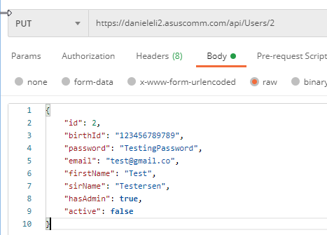

## POST

Opprette ny bruker

tes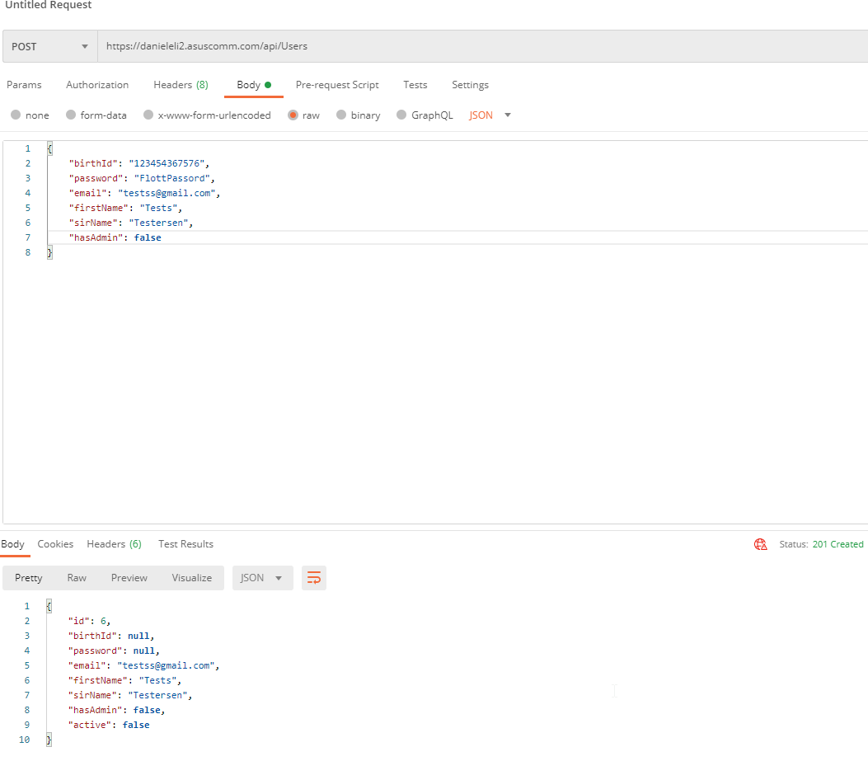

Sjekker identitet

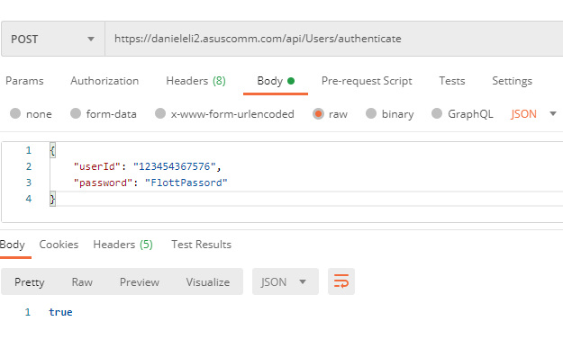

## DELETE

Soft delete av brukeren

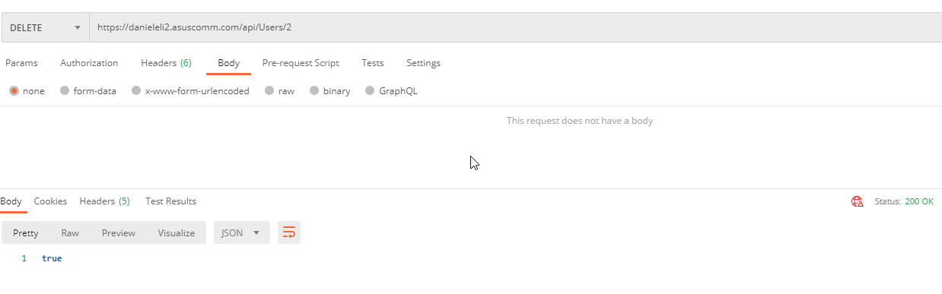

# Kontroller [BadEvents](https://danieleli2.asuscomm.com/api/BadEvents)

## GET

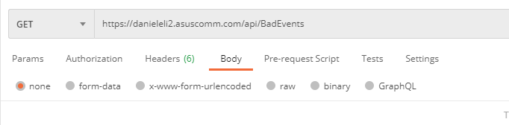

Svar:

[{"id":10,"message":"Overflod","reason":"Mye regn","placement":"Gang","date":"2020-11-18T11:25:00","severityId":5,"statusId":1},{"id":11,"message":"Overflod","reason":"Mye regn","placement":"Gang","date":"2020-11-18T11:25:00","severityId":5,"statusId":1}]18T11:25:00","severityId":5,"statusId":1}]

Enkelt event:

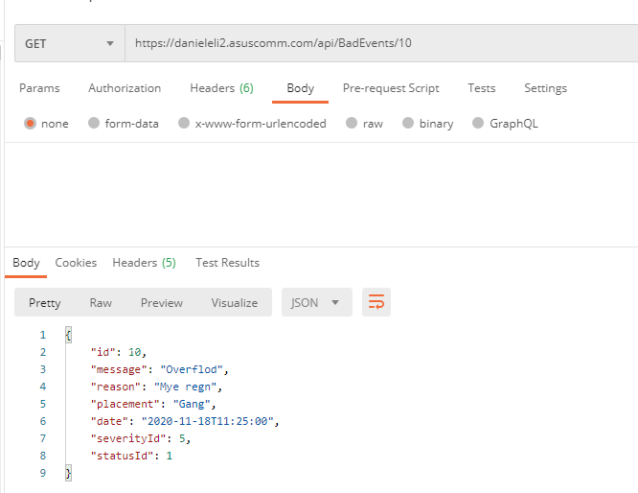

Arkiv:

Henter arkiverte events.

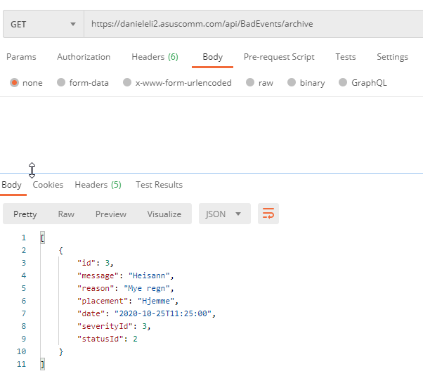

## PUT

Endrer objektet

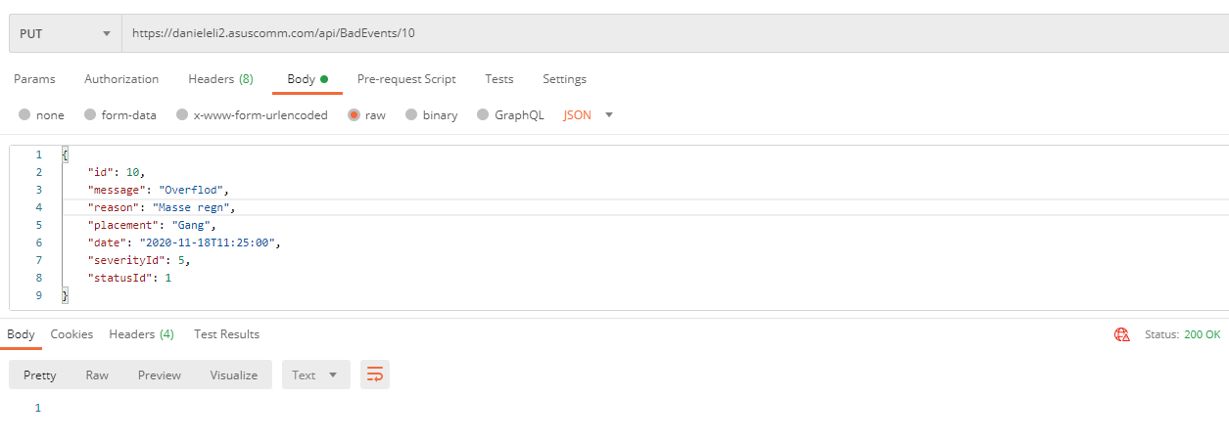

Arkivering av objekt

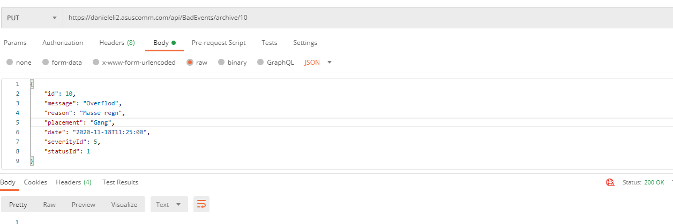

## POST

Oppretter event

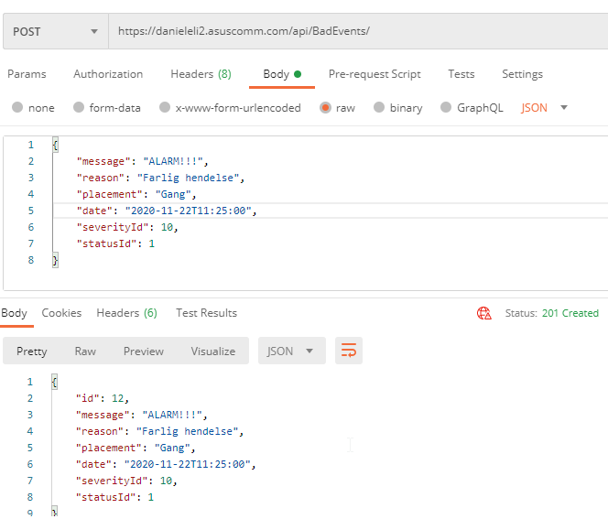

## DELETE

Soft delete av event

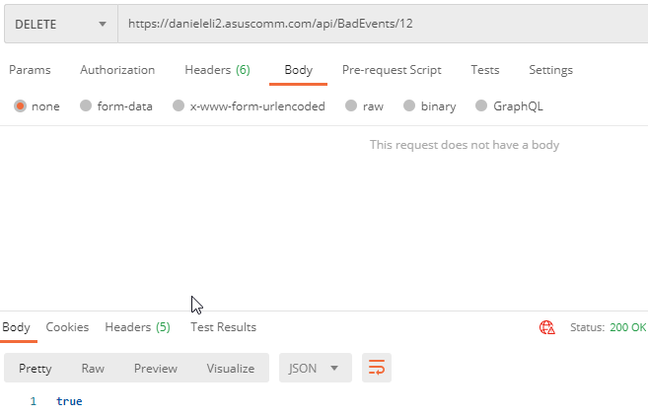

# Kontroller [Reminders](https://danieleli2.asuscomm.com/api/Reminders)

## GET

